GOOGLE CLOUD CICD PIPE-LINE

Pre-requisites:

1.visual studio 2022

2. Docker Desktop

3.Google cloud subscription

Content:

--- Create web api project using asp.net core6 web api

-- Cloud Source Repository

---- Artifact Repository

-- Cloud Build

--- Cloud Run

Step:

create google account

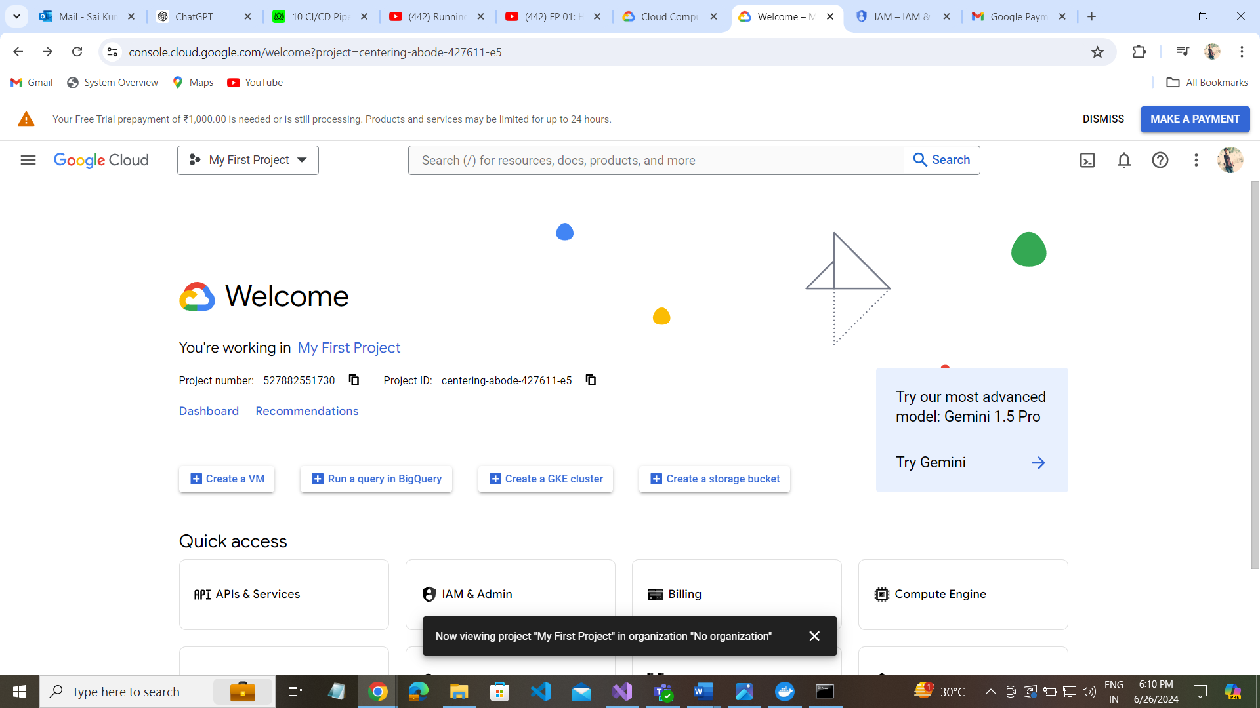

Create project:

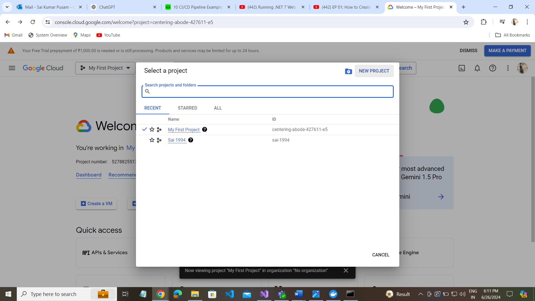

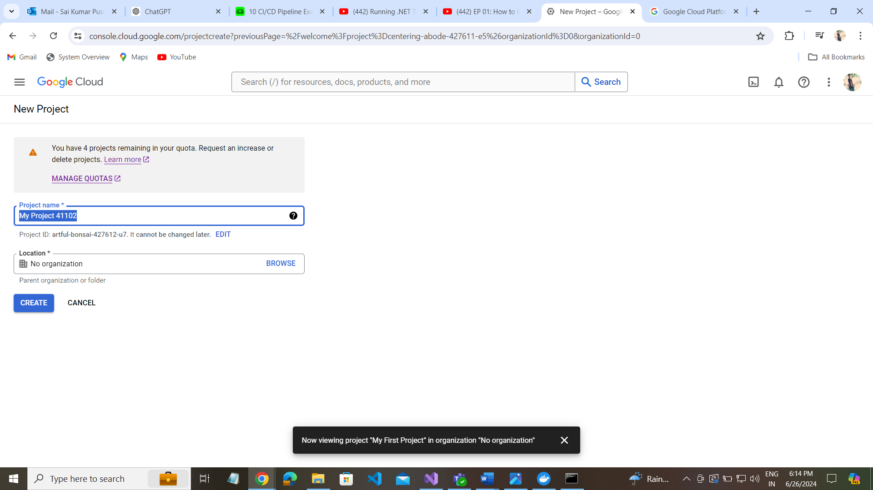

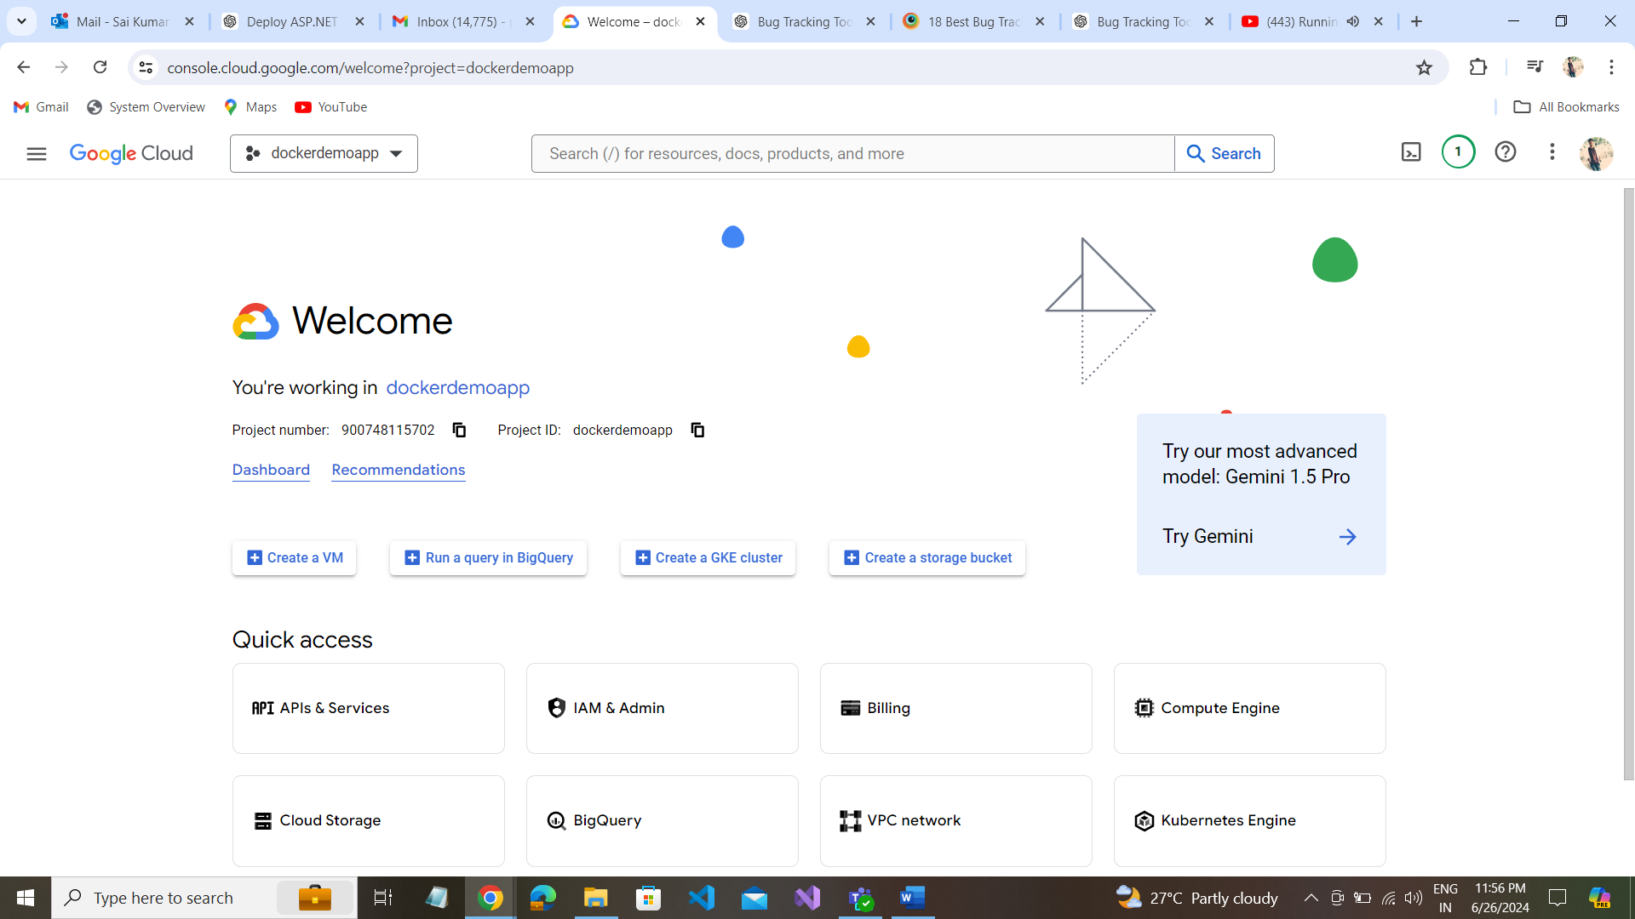

Create cloud source repository:

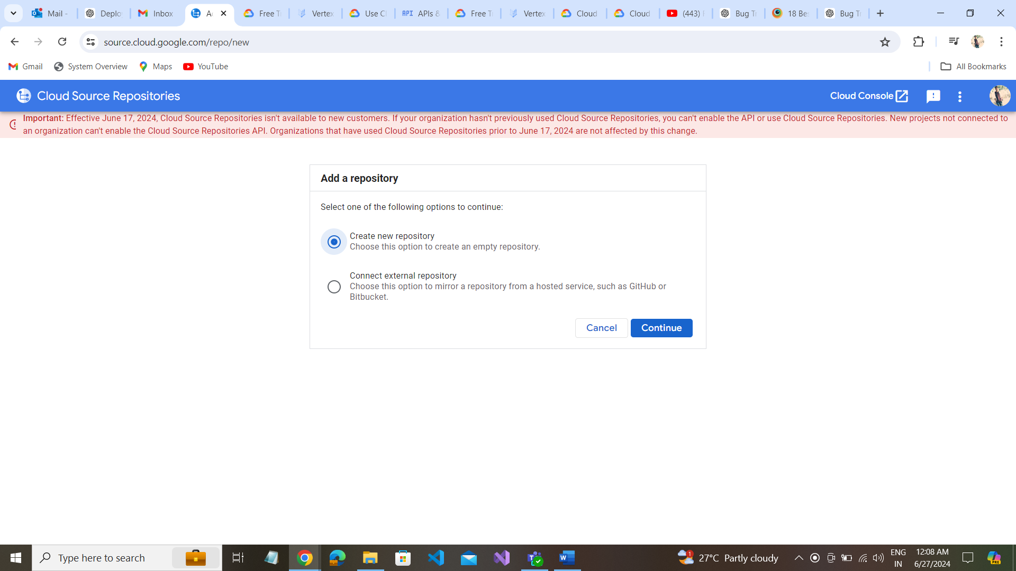

Before create cloud source repository make IAM Grant Access Permissions.

Go to IAM ---- GrantAccess ---

--- select project file

--- email address

--- source repository ----- source repository reader

Save

